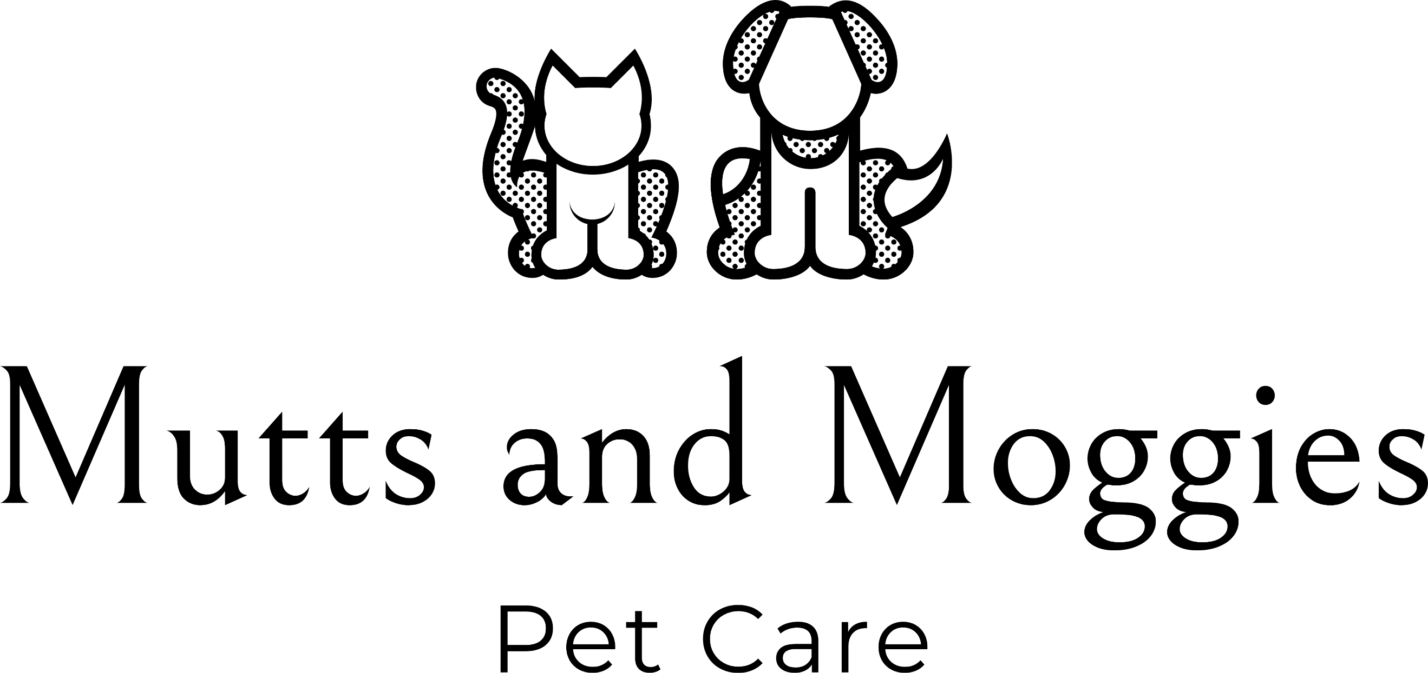

Dog Walking Form

Client Name
Address

Telephone Number
Email

Emergency Contact Name,
Phone Number, Address and
Email Address

Dog’s name(s)
Sex
Breed
Is your dog spayed/neutered
Date of Birth
Physical description of your
dog (size, colour and
distinguishing features).
Microchip Number

Vet’s Name, address and phone number
Dog’s Temperament

Is your dog friendly with other dogs? (On and off lead)
Are there any breeds of dog that your dog does not get along with?
Is your dog friendly with
children?
Has your dog ever displayed
any aggressive behaviour?
Does your dog have any medical conditions?
Is your dog allergic or intolerant to anything?
Are there any particular commands you use with your dog?
Date service commences
Preferred time of walk
Number of walks per week
Preferred walking route
Length of walk
Other care required (e.g. medication, feeding)

Dog Walking Off-lead Disclaimer

I, ____________________________________________

Of (address)______________________________________________________________

have requested that MUTTS AND MOGGIES PET CARE walk my dog(s):________________________________________________________________
off the lead, when in a suitable environment away from roads and traffic. I agree that I cannot hold MUTTS AND MOGGIES PET CARE responsible for loss or injury incurred (of/to my own dog or to another animal or person) as a result, unless they are shown to be negligent.
Signature:______________________________________ Date:____________________

Key Release

I have released a set of house keys to MUTTS AND MOGGIES PET CARE and consent to them holding these keys and entering my property for the purposes of this contract. I understand that no liability can be attached to MUTTS AND MOGGIES PET CARE if a non-related third party (such as a nanny or cleaner) shares access to my property or pets.

Client signature:___________________________________
Service provider signature:__________________________
Date: ____________________

