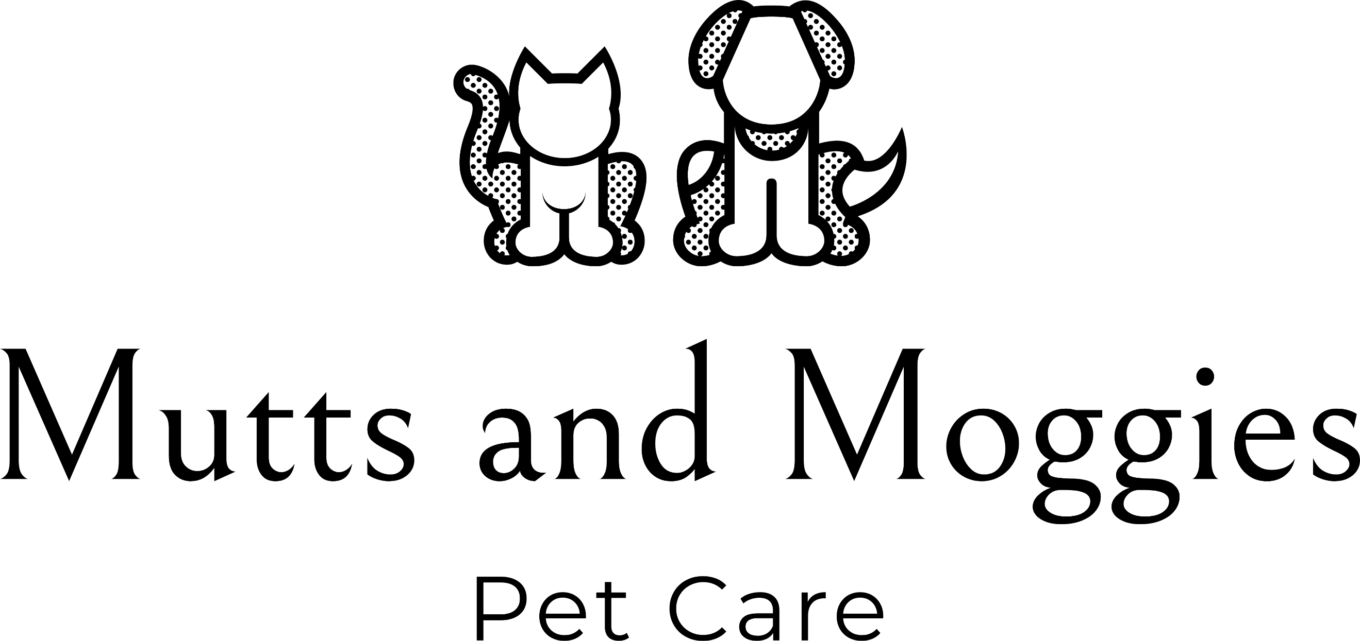

Puppy Sitting Information Form

Client Name
Address

Telephone Number
Email

Emergency Contact Name,
Phone Number, Address and
Email Address

Dog’s name(s)
Sex
Breed
Date of birth
Is your dog spayed/neutered
Physical description of your
dog (size, colour and
distinguishing features).
Microchip Number

Vet’s Name, address and phone number
Dog’s Temperament

Is your dog friendly with
children?
Has your dog ever displayed
any aggressive behaviour?
Does your dog have any medical conditions?
Is your dog allergic or intolerant to anything?
Are there any particular commands you use with your dog?
Other care required (e.g. medication, feeding)

Booking Details

Dates required: ____________________________________________
Number of 1 hour visits per day: ______
Times of visits:______________________________________
Contact after each visit?: Yes / No
Preferred method of contact:___________________

Key Release

I have released a set of house keys to MUTTS AND MOGGIES PET CARE and consent to them holding these keys and entering my property for the purposes of this contract. I understand that no liability can be attached to MUTTS AND MOGGIES PET CARE if a non-related third party (such as a nanny or cleaner) shares access to my property or pets.

Client name: Service provider signature:
Client signature: Date:
Terms and conditions - General

The client agrees to provide full and honest information to MUTTS AND MOGGIES PET CARE about their pets during the booking procedures. Behaviour which may negatively impact employees of MUTTS AND MOGGIES PET CARE should be disclosed at the time of booking.

The client agrees that if their pet attacks another animal or person, including any representative of MUTTS AND MOGGIES PET CARE, and this results in injury to that animal or person, they will be responsible for any expense incurred as a result. This includes payment of veterinary fees incurred as a result of injuries to another animal caused by their pet.

Clients agree to an introductory meeting to allow the carer to meet the pet(s) and discuss aspects of care. This meeting will usually take place in the client’s home by arrangement and is provided free of charge.

You will either ensure that access is given to Mutts and Moggies Pet Care to enter the address at the agreed times or give Mutts and Moggies Pet Care a key to the place where the pet is kept. Mutts and Moggies Pet Care will use the key to carry out the agreed pet care and for no other purpose and will keep it safe, not let anyone else have it, not copy it and will return it to the Customer on demand.

The client will inform their veterinarian that MUTTS AND MOGGIES PET CARE will be caring for their pets while they are away (or at work) and if possible arrange for card details to be held, so that emergency payments can be made. Any veterinary fees that are incurred for your pets and have been paid by MUTTS AND MOGGIES PET CARE, must be reimbursed immediately on your return. A vet release agreement must be signed.

If a medical emergency arises for the pet, MUTTS AND MOGGIES PET CARE will make every effort to contact the client and their emergency contact. Where time is of the essence, the client authorises MUTTS AND MOGGIES PET CARE to seek medical services at the nearest veterinary practice. The client agrees to reimburse for all services rendered by a veterinarian in accordance with the owners wishes as stated and signed in the veterinary release form.
In the event of serious accident or illness of the carer, the client accepts that alternative emergency cover will be arranged for their pets. This will be done with the involvement of the client’s emergency contact(s) wherever possible.
In the event of inclement weather, flooding, fire, break-in or similar occurrence, MUTTS AND MOGGIES PET CARE will make every attempt to contact the client and agree a plan of action. Where the issue occurs at the client’s home and the client cannot be reached immediately, where action is needed for health, safety and welfare, the client authorises MUTTS AND MOGGIES PET CARE to take any action deemed necessary, including repairs, to make the property safe. The clients agree to reimburse MUTTS AND MOGGIES PET CARE for any repairs carried out.
When a period of more than one month elapses between a booking confirmation and the commencement of service, the client must ensure that MUTTS AND MOGGIES PET CARE are informed of any changes made to the pet’s health, routine or care. The client can do this online via email or sent in writing to MUTTS AND MOGGIES PET CARE.
You grant Mutts and Moggies Pet Care the right and permission to use, reproduce, distribute, and publish any photograph, film or audio and video recording of your pet at any time during the walking and/or pet sitting of your pet.

MUTTS AND MOGGIES PET CARE will carry out all agreed services in a reliable, caring, and trustworthy manner. In consideration of these services and as an express condition thereof, the client waives and relinquishes any and all claims against MUTTS AND MOGGIES PET CARE except those arising from gross negligence or misconduct on the part of MUTTS AND MOGGIES PET CARE.
Personal data collected by Mutts and Moggies Pet Care is treated with the utmost respect and confidentiality in line with the Data Protection Act 2018. (Please see our Data Protection Policy and Privacy Policy for more information).

Any individual walk/visit can be cancelled (by you) up to 9am on the day of the walk, after this we reserve the right to charge for the walk.
The contract may be cancelled by either party at any time providing notice of 7 days is given.
Individual bookings (walks/sittings needed) can be varied from week to week, and will be agreed on a weekly basis, by the Sunday of the previous week. For example, if you want walks on Monday, Wednesday and Friday one week you will need to book these by the preceding Sunday at the latest. Extra bookings can be requested right up to the day of the walk, but availability cannot always be guaranteed.
Payment is due by Sunday afternoon (for that week) unless otherwise agreed.
I, the undersigned, have read and agree to the terms and conditions of using the services of MUTTS AND MOGGIES PET CARE. I confirm that I will be responsible for any costs which might be incurred, either veterinary or other, as a result of any sickness, accident or damage caused to or by the pet named overleaf, excepting third party liability, and that I will pay such costs or expenses as required.
Should MUTTS AND MOGGIES PET CARE be required to expend any funds for the care of, or due to damages caused by, your pet, during the pendency of this Agreement, I agree to
compensate MUTTS AND MOGGIES PET CARE completely and to hold harmless MUTTS AND MOGGIES PET CARE for any liability it may incur as a result of this care.

Client name: Service provider signature:
Client signature: Date:

