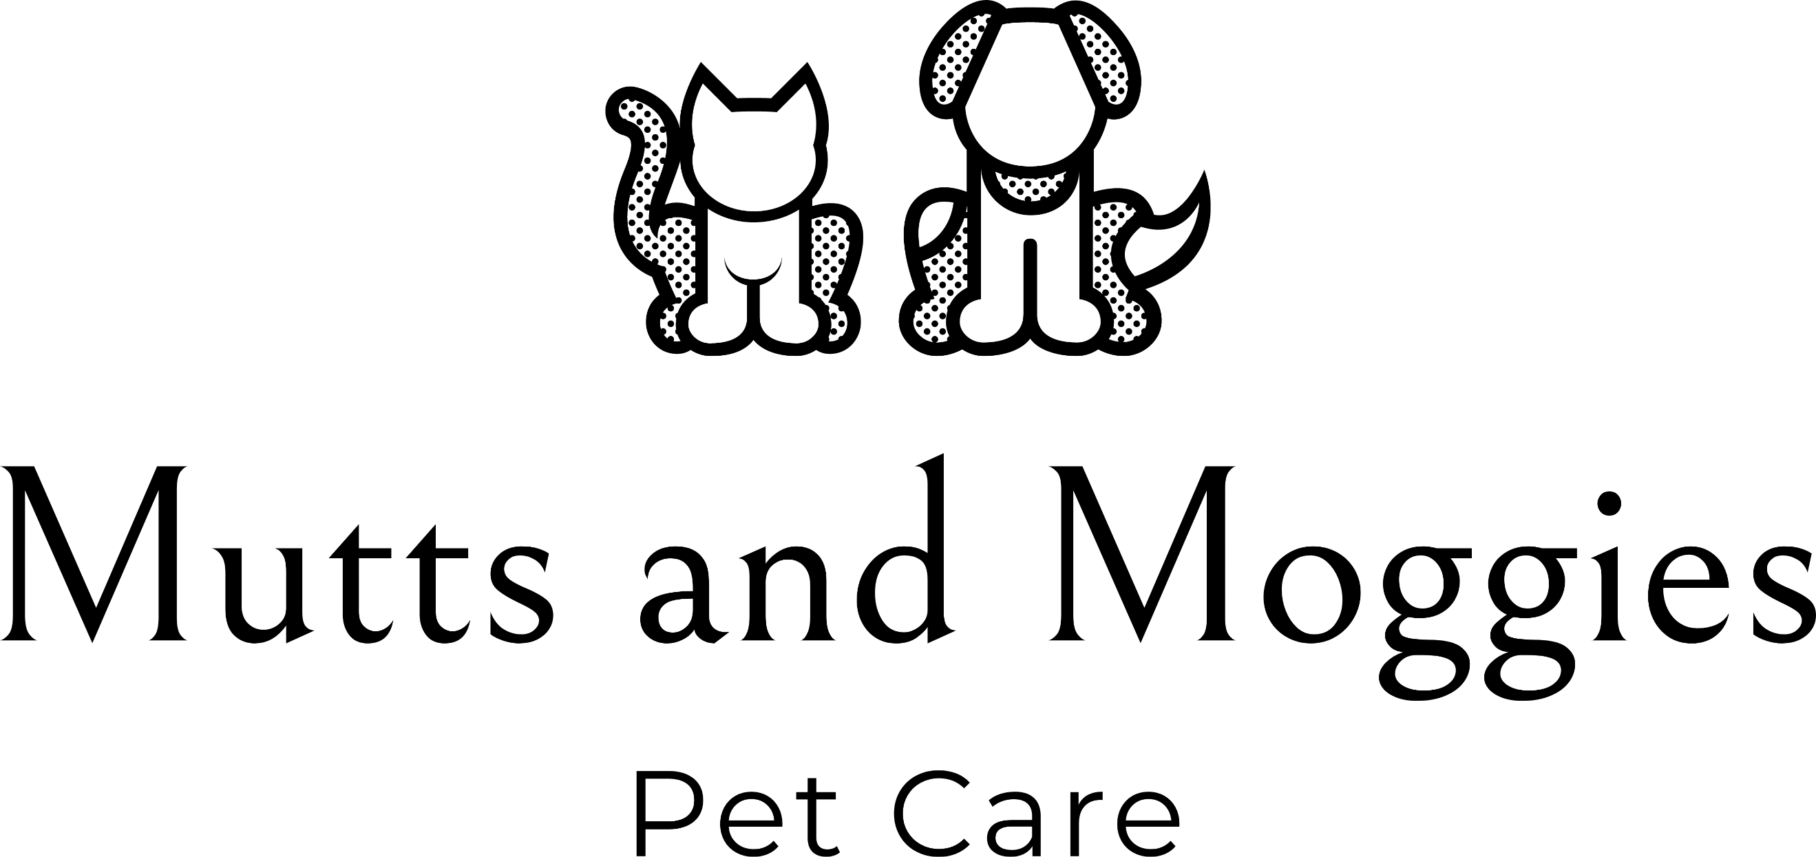

Covid-19 - Dog Walking Protocol

Due to the ongoing risk of the spread of Covid-19 I have put in place some extra precautions in order to help protect both you and myself. Having checked with my insurance company, I can confirm that I am covered to work “as long as you comply with any relevant laws and regulations, and follow any government guidance.” (Protectivity Insurance) I hope this will be of some reassurance to you at this unusual time.
There is currently no proof that Covid-19 can be transmitted between pets and humans, however, there is the potential that it could be carried on their fur. For this reason, I will, unfortunately, have to minimise contact with your dog and will frequently wash my hands using alcohol gel or soap and water.
On entering your property I will attach one of my own leads and collect your dog as quickly and safely as possible to minimise time spent inside. According to the Canine and Feline Sector Group, it is recommended that dogs are wiped down with water at the time of collection and drop off. I will be using biodegradable bamboo wipes (99% purified water with aloe vera and fruit extract). Once used, the wipe will be placed in a dog poo bag immediately and disposed of in a waste bin.
Your dog will remain on lead to ensure that I am able to maintain the required 2m social distance at all times.
On return, as before, I will spend as little time as possible inside your property whilst ensuring your dog is safe. Once I have removed the lead I will place it in a bag so that I can wash it when I get home.
In terms of payment, for the time being I will only be accepting bank transfer due to the risks associated with handling cash. Please inform me if you would like me to invoice you and if you would prefer it weekly or monthly.
If any member of your household are showing symptoms related to Covid-19 please let me know as soon as possible. If you would like walks to continue I will need to add to this protocol. If for any other reason there will be someone in the property when I collect/drop off your dog I will need to be aware of this prior to arrival. As further guidance is released I will update this document and send to you again, highlighting the changes.

