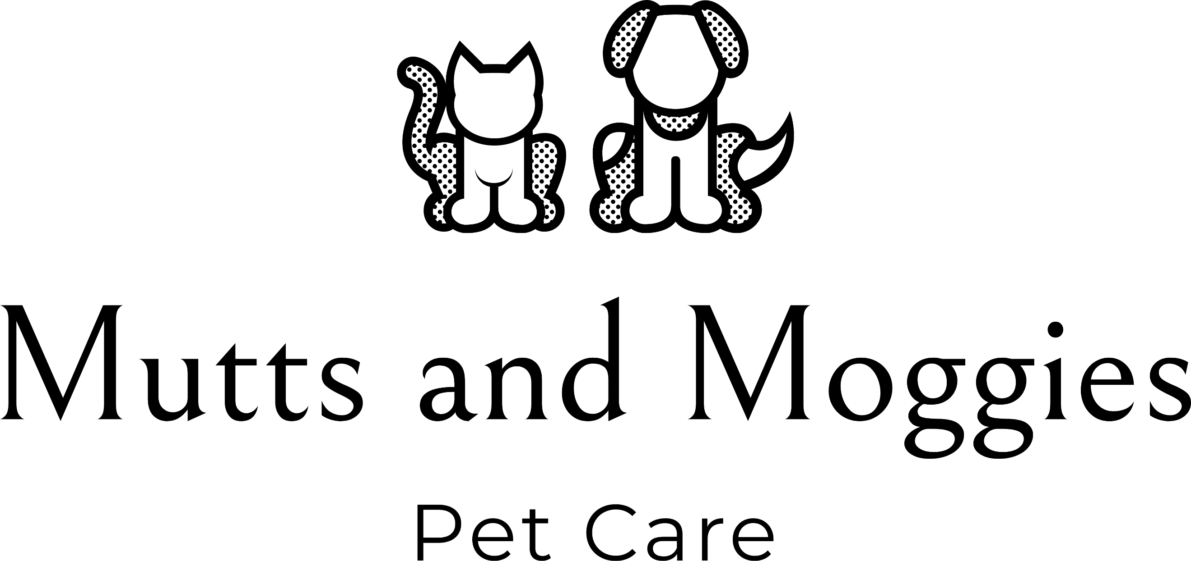

General Data Protection Regulation (GDPR)

Data Protection Policy

Policy brief & purpose

Mutts and Moggies Pet Care’s Data Protection Policy refers to our commitment to treat information of employees, customers and other interested parties with the utmost care and confidentiality.
With this policy, we ensure that we gather, store and handle data fairly, transparently and with respect towards individual rights.

Scope

This policy refers to all parties (employees, job candidates, customers, suppliers etc.) who provide any amount of information to us.

Who is covered under the Data Protection Policy?

Employees of our company and its subsidiaries must follow this policy. Contractors, consultants, partners and any other external entity are also covered. Generally, our policy refers to anyone we collaborate with or acts on our behalf and may need occasional access to data.

Policy elements

As part of our operations, we need to obtain and process information. This information includes any offline or online data that makes a person identifiable such as names, addresses, usernames and passwords, digital footprints, photographs, social security numbers, financial data etc.
Our company collects this information in a transparent way and only with the full cooperation and knowledge of interested parties. Once this information is available to us, the following rules apply.

Our data will be:
- Accurate and kept up-to-date
- Collected fairly and for lawful purposes only
- Processed by the company within its legal and moral boundaries
- Protected against any unauthorized or illegal access by internal or external parties

Our data will not be:
- Communicated informally
- Stored for more than a specified amount of time
- Transferred to organizations, states or countries that do not have adequate data protection policies
- Distributed to any party other than the ones agreed upon by the data’s owner (exempting legitimate requests from law enforcement authorities)

In addition to ways of handling the data the company has direct obligations towards people to whom the data belongs.

Specifically we must:
- Let people know which of their data is collected
- Inform people about how we’ll process their data
- Inform people about who has access to their information
- Have provisions in cases of lost, corrupted or compromised data
- Allow people to request that we modify, erase, reduce or correct data contained in our databases

Actions

To exercise data protection we’re committed to:
Restrict and monitor access to sensitive data
Develop transparent data collection procedures
Train employees in online privacy and security measures
Build secure networks to protect online data from cyberattacks
Establish clear procedures for reporting privacy breaches or data misuse
Include contract clauses or communicate statements on how we handle data
Establish data protection practices (document shredding, secure locks, data encryption,
frequent backups, access authorization etc.)
Our data protection provisions will appear on our website.

Disciplinary Consequences

All principles described in this policy must be strictly followed. A breach of data protection guidelines will invoke disciplinary and possibly legal action.

Privacy Notice

Here at Mutts and Moggies Pet Care we are committed to protecting and respecting your privacy.
What do we need?
Data we collect may consist of names, e-mail addresses, addresses, phone number, details of your pets and the vets you are registered with. We will only collect data that is necessary to effectively provide a pet care service to you.
Why do we need it?
We will only use your personal information to enable us to provide you with the best possible pet care service.
What do we do with it?
Personal data is only processed by a member of the Mutts and Moggies Pet Care team and will never be sold on or shared with third parties.
How long do we keep it?
We are required under UK tax law to keep your basic personal data (name, address, contact details) for a minimum of 7 years after which time it will be destroyed.
Your rights
You have the right, at any time, to request a copy of all the data we hold about you. You can request to have all of your data deleted at any time (however, this may prevent us from being able to provide a pet care service to you).
If you believe that any of the information we hold about you is incorrect, please do contact us so it can be rectified.

To make any of these requests, please e-mail us at hello@mmpetcare.co.uk

